The Altruism Project

Author : [Swapan](https://quarantinehackathon.devpost.com/) Roy

Contents

The Pitch : 1

Problem Statement 1

The COVID -19 angle 2

Approach : 3

Solution : 3

End to End Flow 7

Sources 8

# The Pitch :

The pathogenic pandemic has forced people to alter their routine, the inability to interact the way they would like, impacting their mental health. The proposed solution will assist people to overcome their current state and give a platform on which they can depend on after pandemic is over.

# Problem Statement

People in every country suffer from Mental Health related issues, which gets amplified in a pandemic environment. A deliberate effort needs to be made to reach out to people who need help.

* Our World in Data reports, there are 792 million people with mental disorders around the world.
* Egypt Today report – 25 % of Egyptians suffer from Mental Health related issues.
* 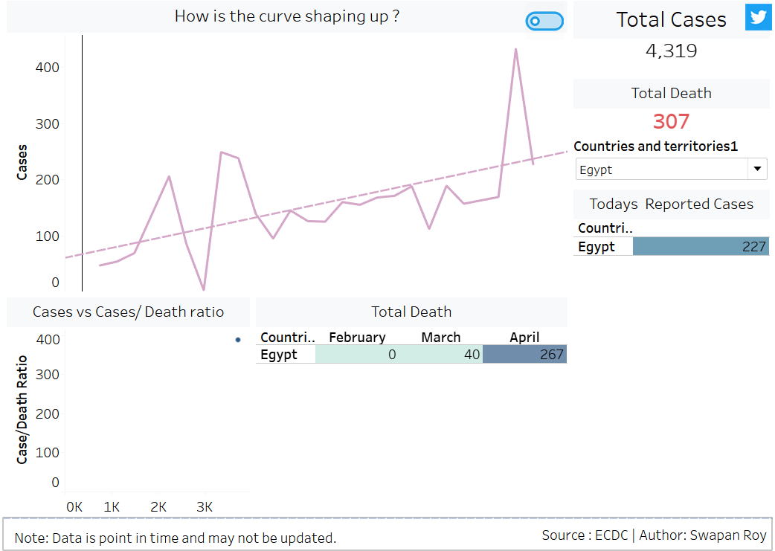

# The COVID -19 angle

* Covid-19 has made social distancing a new norm, it will take years for people to completely get over it.
* Everyone is fighting the pandemic on their own, we need a community to support
* The image on the side shows how Egypt is dealing with it.

# Approach :

The overall solution has an online and offline component. The solution framework consists of utilizing various freely available resources to gauze the personality of an individual. Once the personality (psychology) test has gauzed an individual, amongst the pool of individuals we choose an individual with sound personality with age and professional acumen as a “ community leader”, other people in the pool will be referred to as “Individuals”. Based on interest, individuals will be paired with leaders who can set a 30 - 45 min meeting agenda which can include talking on sports or exercising, meditation, or instructing on cooking recipes. Such meetings will be randomly monitored by therapists, psychologists, and nurse practitioners. After 3 weeks the leader will be asked to provide status on how the group is doing and each individual shall be asked to re-take the personality test. Comparing the new and old data, we can gauze progress.

# Solution :

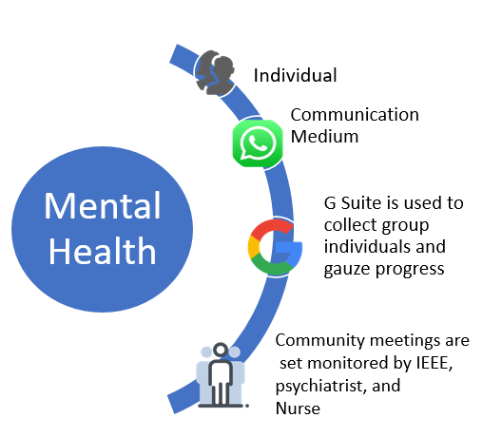

Whatsapp will be used as a prime mode of communication along with video sharing platforms like google meet or zoom. Individuals can request for help via a Whatsapp number, they will be asked to take a personality test free via (<https://www.psychologytoday.com/intl/tests/health/mental-health-assessment> or some other free source) and be asked to enter their values to a google “Get to know“ form.

Below is a sample screen print of a mental health assessment test from psychologytoday.com

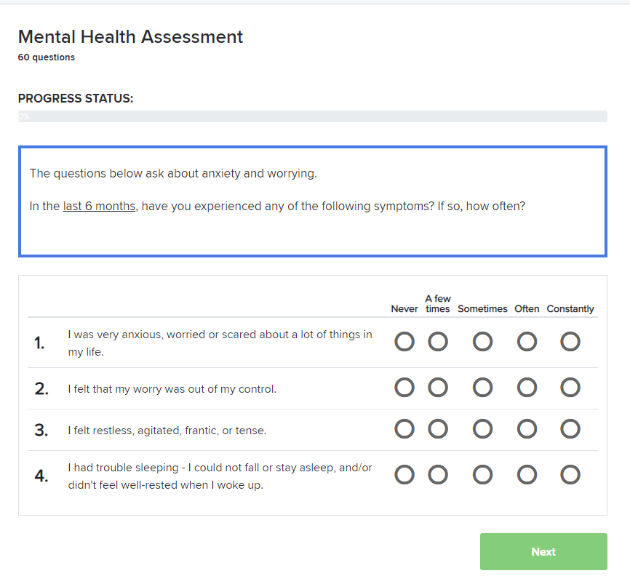

Below is a sample Mental Health assessment results

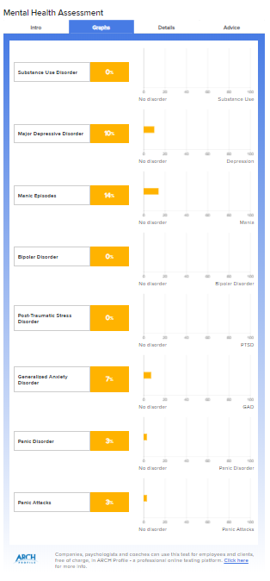

After taking tests, Individuals will be provided results. They need to enter the values they got on the test onto a google form.

Below is the sample Google forms which can be embedded in an introduction email or shared by WhatsApp.

<https://docs.google.com/forms/d/e/1FAIpQLSf8Matfo1r3-sb2HBp4RXCoWc57msRPH7qrQXwSwZnL5ov7Mw/viewform>

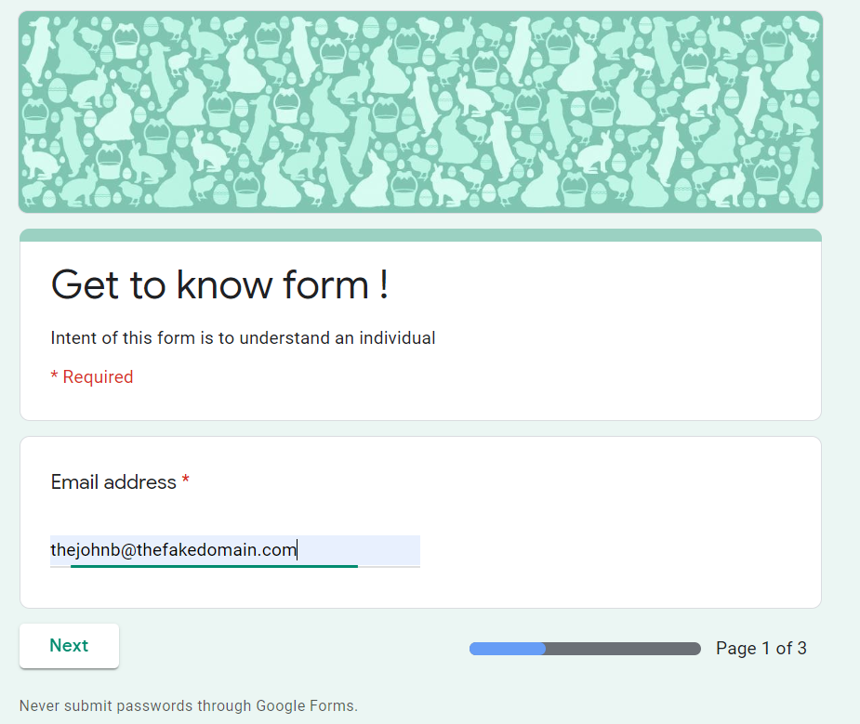

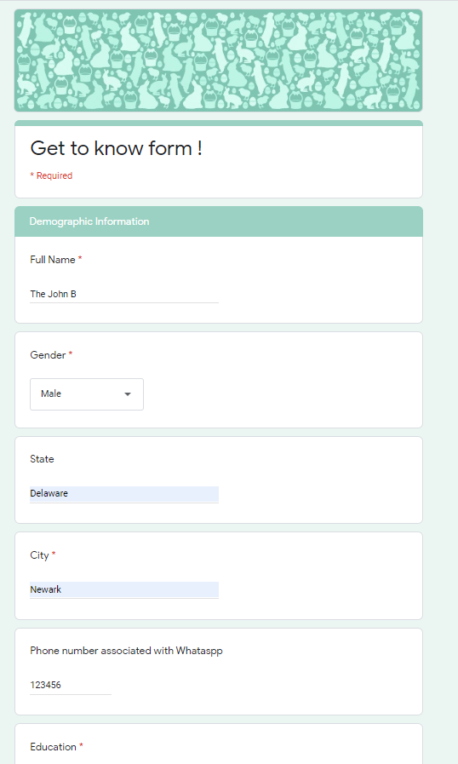

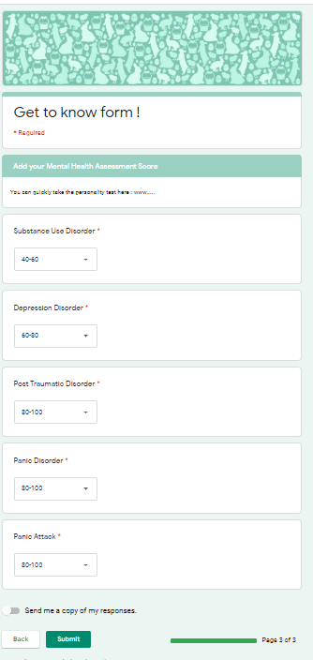

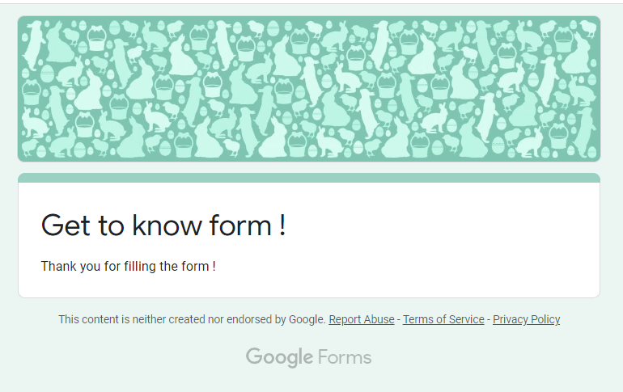

The results will be saved in google sheet

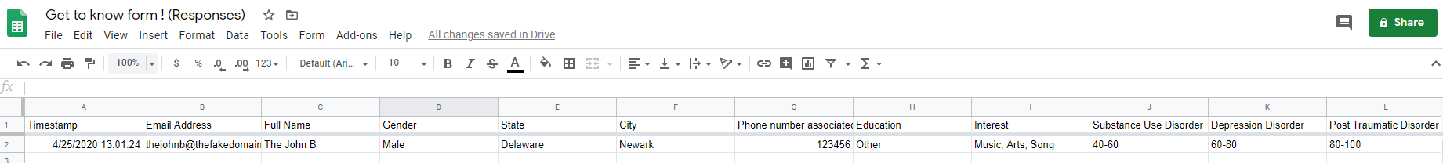

Once data is collected, Community leaders will be selected and trained. Four to Seven Individuals will be grouped with community leaders based on their preferences and location.

A leader will oversee the meetings, randomly monitored by a nurse practitioner or a psychiatrist to gauze influence.

If an individual is not making progress, that person will be referred to additional help.

# End to End Flow

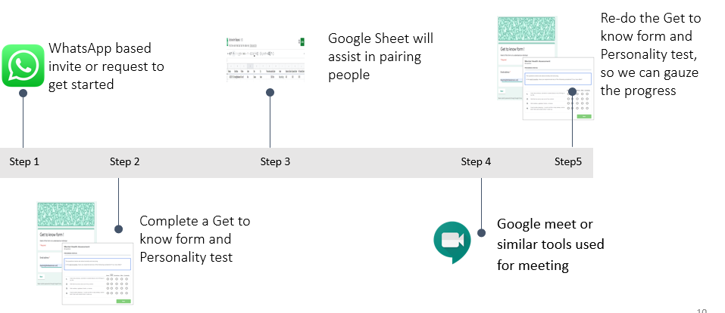

Sources

<https://www.psychologytoday.com/us/tests/health/mental-health-assessment>

<https://www.ginger.io/app>

<https://www.egypttoday.com/Article/1/48156/25-of-Egyptians-suffer-from-mental-health-issues-survey>

<https://www.worldometers.info/world-population/egypt-population/>

<https://worldpopulationreview.com/>

<https://psychometer.shezlong.com/en/result/511335> (For psychometric test)

<https://ourworldindata.org/mental-health>

<https://www.al-monitor.com/pulse/originals/2016/12/egypt-online-startup-fight-depression-shezlong.html>

<https://www.shezlong.com/> (Online help for a fee)